Protocol: Determining Focus Learning Targets

The purpose of this protocol is to accelerate the process of determining “focus learning targets” in the instructional roadmap design process.

This protocol should be used after all of the priority/power standards have been unwrapped.

- Individually, decide which learning targets are the most critical or important concepts or skills.
- Compare lists with teammates.
- If there is agreement about a particular learning target being included or not included, there is no need to discuss it.
- If there is disagreement about a particular learning target being included or not included, provide each team member in the minority to explain their thinking for wanting to include or exclude a particular learning target.
- After every team member has had an opportunity to discuss their opinions, attempt to establish consensus (has the group’s opinion been swayed? Can the dissenters live with the will of the group?)

Proficiency Level Descriptions – General Description
 | Descriptions of Proficiency Levels
4 | In addition to exhibiting level 3 performance, in-depth inferences and applications that go beyond what was taught in class | Advanced
3 | No major errors or omissions regarding any of the information and/or processes (simple or complex) that were explicitly taught (usually Webb’s DOK 3 & 4) | Proficient
2 | No major errors or omissions regarding the simpler details and processes, but major errors regarding the more complex ideas and processes (usually Webb’s DOK 1 & 2) | Approaching
1 | With help, a partial knowledge of some of the simpler and complex details and processes | Emerging

Proficiency Level Descriptions – Example
Learning Target | I can analyze the development of a theme over the course of a text, including its relationship to literary elements (character, setting, plot).
4 | Evaluate which literary element most influences the theme of the story | Advanced
3 | Write an analysis that includes the theme of the story, and at least 2 specific examples of textual evidence relating to character, setting, or plot that support the theme | Proficient
2 | Determine the theme of the story | Approaching
1 | With prompting about character, setting, and/or plot, determine the theme of the story | Emerging

Example – Summative Assessment

1. Standard 8.R.I.1
Learning Targets:
- I can cite textual evidence that supports my analysis of an informational text.

Directions:
Read the passage below. As you read, determine your position on the issue.

[insert article here]

Write a statement that demonstrates your position. Defend your position with at least two pieces of evidence either directly from the text, or that can be inferred from the article.

2. Standard 8.R.L.1
Learning Targets:
- I can cite textual evidence that supports my analysis of a literary text.

Directions:
Read the following poem. Ask yourself the following questions as you read.
- What did you think, notice, or wonder?
- Whom is the poet addressing?
- What feelings does this poem evoke?
- What message is the author trying to get across?

[insert poem here]

In a short paragraph, try to answer some of the questions above. What lines or words from the poem help you to answer the questions?

3. Standard 8.L.4.a
Learning Target:
- I can use the overall meaning of a sentence to determine the meaning of an unknown word or phrase.

Directions:
Read Line 5 from the poem:

“One grasped in each sinewy hand”

What does sinewy mean?

a. difficult to chew
b. lean and muscular (correct answer)
c. chubby and soft

Read line 12 from the poem:

“quacking foul and boisterous as”

What does boisterous mean?

a. quiet and peaceful
b. cocky and confident
c. loud and noisy (correct answer)

4. Standard 8.W.4
Learning Targets:
- I consider my audience when I write.
- I consider my purpose for writing.

Directions:
Complete the 1 topic = 25 topics and audiences graphic organizer in your writing notebook.

6th Grade Science Pretest

- What does mass measure?
  - The amount of space something takes up.
  - The amount of matter in an object.
  - The pull of gravity on an object.
  - The distance from one point to another.

- What does volume measure?
  - The amount of space something takes up.
  - The amount of matter in an object.
  - The pull of gravity on an object.
  - The distance from one point to another

- What does weight measure?
  - The amount of space something takes up.
  - The amount of matter in an object.
  - The pull of gravity on an object.
  - The distance from one point to another.

- What does length measure?
  - The amount of space something takes up.
  - The amount of matter in an object.
  - The pull of gravity on an object.
  - The distance from one point to another.

- What unit would you use to measure the volume of water in a bottle?
  - Meter
  - Liter
  - Gram
  - Pound

- What unit would you use to measure the distance from one class to another?
  - Meter
  - Liter
  - Gram
  - Pound

- What unit would you use to measure the mass of a Science book?
  - Meter
  - Liter
  - Gram
  - Pound

Write the answer on the appropriate line.

- Measure the line below to the nearest tenth of a cm and nearest mm.

________cm __________mm

- Write out the term for the following symbols.
a. kg __________________ b. mL__________________ c. mm __________________

- Convert the following measurements.

a. 1 km = ____m b. 1 m =____cm c. 1 L = ____mL
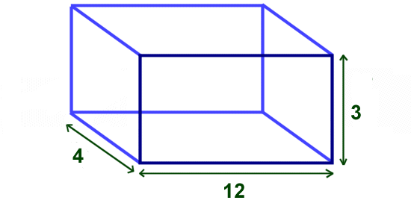
- Find the volume of this cube in cm³. Show your work in the space below.
Answer: ____________________________________________

- What is the volume of the fish? Show your work in the space below.
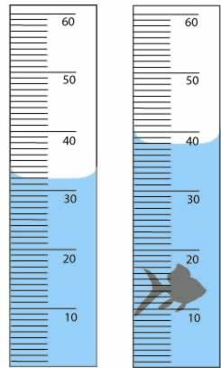
Answer: ____________________________________________

- What unit would you use to measure the distance from Rapid City to New York City?

- What unit would you use to measure the amount of liquid in a cup?

Protocol: Determining CFA Learning Targets

The purpose of this protocol is to help determine which learning targets should have CFAs written around them in the instructional roadmap design process.

This protocol should be used after focus learning targets have been established and proficiency level descriptions have been written.

- Individually, apply the following criteria to the focus learning targets:
  - Which targets are most likely to cause students difficulty?
  - Which targets are prerequisite skills or knowledge?
  - Which targets are absolutely essential?
Any target that meets all three criteria should be considered for a CFA.

- Compare lists with teammates.
- If there is agreement about a particular learning target being included or not included, there is no need to discuss it.
- If there is disagreement about a particular learning target being included or not included, provide each team member in the minority to explain their thinking for wanting to include or exclude a particular learning target.
- After every team member has had an opportunity to discuss their opinions, attempt to establish consensus (has the group’s opinion been swayed? Can the dissenters live with the will of the group?)

